Abstract—This paper describes the parallelization of a membrane computing architecture in solving cost-based abduction (CBA) optimization problems. Membrane systems are a class of distributed, massively parallel and non-deterministic data structures based on the biological metaphor of cells and cell processes. As such, algorithms based on these cell processes are suitable for implementation on parallel machines, and because of the localized nature of the communication between cells, load balancing is easier to predict and dynamically evaluate. Cost-based abduction is an important problem in reasoning in uncertainty with applications in medical diagnostics, natural language processing, belief revision, and automated planning. In this paper, we will describe a membrane architecture used to search for optimal solutions to cost-based abduction problems, compare the performance of this algorithm to other published techniques and present empirical results on the parallelization in a cluster computing environment.
The Parallelization of Membrane Computers to Find Near Optimal Solutions to Cost-Based Abduction
Curry I. Guinn, William Shipman, and Ed Addison
Index Terms—Membrane computing, cost-based abduction, cluster computing, and genetic algorithms.

INTRODUCTION
Membrane computing is a biologically-inspired branch of natural computing, abstracting computing models from the structure and functioning of living cells and from the organization of cells in tissues or other higher order structures [1]. The basic elements of a membrane system (also known as a P-System after Gheorghe Păun) are the membrane structure and the sets of evolution rules which process multisets of objects placed in the compartments of the membrane architecture (Figure 1). A membrane structure is a hierarchically arranged set of membranes. Objects within membranes evolve through a set of rules which may combine objects, mutate objects, delete objects, or pass objects through membranes. Rules potentially can change membrane structures themselves (dissolving, dividing or creating membranes). Object selection and rule selection is a non-deterministic process. Certain classes of membrane architectures have been shown to be equivalent to Turing Machines and thus are capable of any computation. The specific membrane architecture we employ will be described in more detail in Section 3.
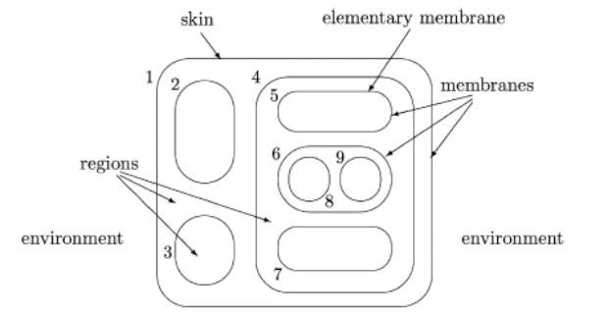
Figure 1 A Membrane Structure (from [2])

Cost-based abduction (CBA) is an important problem in reasoning under uncertainty [3, 4]. Finding Least-Cost Proofs (LCP’s) for CBA systems is known to be NP-hard [4, 5]. Techniques for finding approximations of the least cost solution to CBA problems include best-first heuristic approach [6, 7], integer linear programming [8], binary decision diagrams [9], neural networks [10], ant colony [11], simulated annealing [12, 13], and particle swarm optimization [14]. Chivers et al. showed promise in the use of genetic algorithms for finding approximate solutions [15]. In our experiments, we directly contrast our results with [12], [13], [14] and [15] which use the same CBA problem set.
Our approach is to use a membrane architecture to exploit the inherit parallelism of the architecture combined with the genetic recombination of strings. A possible solution to the CBA problem is represented as a string with each bit of the string representing whether a particular hypothesis is assumed to be true or false. Candidate solutions are placed in an inner membrane. To pass to the parent membrane, solutions must be repaired so that they actually prove the goal. In the parent membrane several string manipulations (or using the cell metaphor, chemical reactions) may occur including genetic splicing, deletion, and passing to an upper membrane. Membranes can be arranged hierarchically to any level of depth and with any branching factor. Part of our study was investigating which configurations or topologies of membranes resulted in faster convergence to approximate solutions.

In the sections that follow, we will describe the cost-based abduction problem in detail, present the membrane architecture employed to solve these problems, provide the specific implementation of the membrane computer, and contrast our experimental results with other published work. We conclude with a discussion of these results and further research.

Cost-Based Abduction (CBA)
Abduction is the process of proceeding from data describing observations or events, to a set of hypotheses, which best explains or accounts for the data [3]. Abduction is a method employed in a variety of application domains including medical diagnostics, natural language processing, belief revision, and automated planning. Cost-based abduction is a formalism in which evidence to be explained is treated as a goal to be proven, proofs have costs based on how much needs to be assumed to complete the proof, and the set of assumptions needed to complete the least-cost proof are taken as the best explanation for the given evidence.

A CBA system is a knowledge representation in which a given world situation is modeled as a 4-tuple K = (H,R, c, G), where
• H is a set of hypotheses or propositions,
• R is a set of rules of the form
(hi1 ^ hi2 ^ : : : ^ hin)  hik ,
where hi1 ; : : : ; hin (called the antecedents) and hik (called the consequent) are all members of H,
• c is a function c : H  +, where c(h) is called the assumability cost of hypothesis h  H and + denotes the positive reals,
• G  H is called the goal set or the evidence. [4,13]
The objective is to find the least cost proof (LCP) for the evidence, where the cost of a proof is taken to be the sum of the costs of all hypotheses that must be assumed in order to complete the proof. Any given hypothesis can be made true in two ways: it can be assumed to be true, at a cost of its assumability cost, or it can be proved. If a hypothesis occurs as the consequent of a rule R, then it can be proved, at no cost, to be true by making all the antecedents of R true, either by assumption or by proof. If a hypothesis does not appear as the consequent of any rule, then it cannot be proved, it can be made true only by being assumed.

A possible solution to a CBA problem may be represented as a string with each character (or bit) of the string indicating whether a particular hypothesis is true or false. As an example, a 6-bit string 101110 would indicate the hypotheses 1, 3, 4, and 5 are assumed while hypotheses 2 and 6 are not. The cost of the solution is then the sum of the cost of hypotheses 1, 3, 4, and 5. Our membrane architecture will process strings of possible solutions of this form.

One potential problem with any proposed solution is that the assumed hypotheses might not actually be sufficient for proving the goal set. Following Chivers et al [13, 14], we use a repair technique based on a type of stochastic local search. If the hypotheses (represented by the string x) assumed are sufficient to prove the goal, then the fitness of the solution is made equal to the assumability cost of the hypotheses corresponding to the 1-bits of x and no further processing is needed. Otherwise, we randomly choose a 0-bit in the x vector and assign it to 1. If the goal still cannot be proven, then we randomly choose another 0-bit and assign it to 1, until the goal is provable. This process can of course result in many unnecessary hypotheses being assumed. We, therefore, follow up this process with a simple 1-OPT optimization process. We examine each of the 1-bits of the x vector: one by one and in a random order, each 1-bit is assigned to 0 and if the goal can still be proven, then it is retained as 0, otherwise it is set back to 1.

Membrane Architecture for Solving CBA
Our approach is to use a membrane architecture to exploit the inherit parallelism of the architecture combined with genetic recombination of strings [See Figure 2]. Each possible solution to the CBA problem is represented as a string with each bit of the string representing whether a particular hypothesis is assumed to be true or false. Candidate solutions are placed in an inner (Repair) membrane. To pass to the parent membrane, solutions must be repaired so that they actual prove the goal. This repair is done by the manner described in the previous section. Now the string is passed to the parent membrane. In our experiments, the Repair membrane is initially seeded with 50 random strings.

Repair Rule: Grab any string in membrane, repair, and pass to parent membrane.
In the Parent membrane, several chemical reactions (string manipulations) can occur. One reaction grabs a number of hypotheses and deletes the one with highest cost.

Delete Rule: Grab a number of strings within the membrane (in our implementation that number is 7), determine the cost of each hypothesis and delete the lowest.

101011011
10011011 100011
110011
111100
10011011
10011011
Repair
Crossing Rule
Child
Repair
Crossing Rule
Child
Repair
Crossing Rule
Repair
Splice
Child
Repair
10011011 100011
110011
111100
Crossing Rule
Repair
Crossing Rule
Outer Skin
Parent
Parent
GrandParent
Child
Repair
Crossing Rule
Ascend Rule
Feedback Rule
Ascend Rule
Ascend Rule
Ascend Rule
Ascend Rule
Feedback Rule
10011011
10011011 110011
111001 101010
111100 001101
111110
Delete Rule
10011011 100011
110011
111100
10011011 100011
110011
111100
10011011 100011
110011
111100
10011011 100011
110011
111100
10011011 100011
110011
111100
10011011 100011
110011
111100
Figure 2 An Example 1-2-2 Membrane Topology with One Grandparent with Two Parents, Each of Which Have Two Children

Another reaction grabs a number of hypotheses and, after choosing the best two based on cost, crosses them using a point-wise splice to create two children. These children are then passed down to the inner Repair. As an example of a random point-wise cross, imagine two parents ABCDEF and UVWXYZ. If the randomly chosen cross-point is 4, the two children would be ABCDYZ and UVWXEF.
Crossing Rule: Grab a number of strings (3, for instance) and choose the one with the best score. Grab another 3 strings and choose the best. Do a point-wise cross of the two strings at a random point creating two children. Pass the children to the Repair sub-membrane.
Since each cross creates two children, we insure that the probability of a deletion occurring is twice as likely as the probability of a splice. This keeps the population relatively constant.
This membrane structure can be nested so that parents can pass good solutions through a membrane to their parent membrane. This grandparent membrane may perform similar reactions. This nesting can occur to any level desired.
Ascend Rule: Grab a number of strings (6), choose the one with the best score, and pass to parent membrane.
Each membrane potentially could reach a local minimum and obtain no further improvement. One enhancement to the model is to allow parent membranes to occasionally pass down one of its best solutions to a child. This feedback would then cause the child to splice its best solution with this new solution, starting a new cycle of splices and repairs.
Feedback Rule: Grab a number of hypotheses in the membrane (we chose 7), pick the best and send to a randomly chosen child membrane.
One of our goals is to explore topologies of membranes that results in faster convergence towards optimal solutions.

Membrane Architecture for Solving CBA

CBA Problem Set
Our CBA problem set is taken from the standard collection found at www.cbalib.org. Abdelbar has investigated the generation of difficult instances of CBA problems and explored the terrain of that search space [13]. In order to directly compare our results with other published results, we have focused on a particular CBA problem which is the most difficult in the www.cbalib.org library, a problem labeled raa180. The exact optimal solution is known for this problem by using an integer linear program (ILP) using Santos’ method [8]. The data in Table 1 (obtained from [12, Table I]) describes raa180 as a problem with 300 hypotheses, 900 rules, and an optimal solution cost of 10,821. Notice that the ILP solution required over a day of CPU time.

Instance | raa180
No. of hypotheses | 300
No. of rules | 900
No. of assumable hypotheses | 180
Rule depth | max: 38, avg: 25.0  median: 27
Optimal solution cost | 10,821
ILP CPU time (sec) | 88,835
ILP tree depth | 41
ILP nodes | 178,313
Table 1 Characteristics of CBA Instance raa180

Membrane Computer Implementation
Our implementation of the membrane computer is accomplished using the Lexxle P-System/ABC System Toolkit by Lexxle, Inc. developed specifically for use on cluster computers. Design and testing of the architecture is accomplished using a graphical user interface supported by the GridNexus software developed at the University of North Carolina Wilmington. A sample screenshot is given in Figure 2.
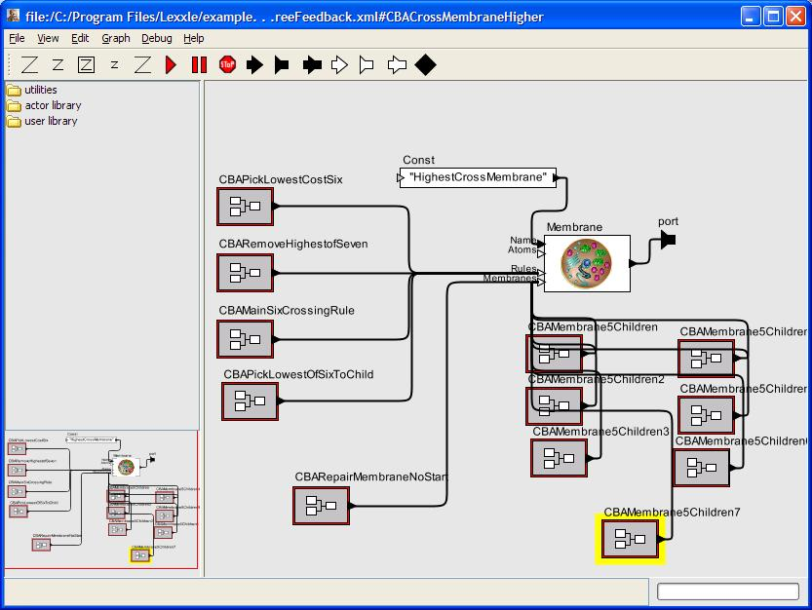
Figure 1 Screenshot of the Lexxle P-System/ABC System Interface

Using this Toolkit, we were able to create membranes and submembranes, insert multisets into the membranes, create string manipulation rules for each membrane, and run the simulation for a given number of iterations or for a set time.

Experimental Results
Our experimental goals were three-fold:
1) To compare our results to those published by Abdelbar et al [12,13] and by Chivers et al [14,15],
2) To explore which topologies of membranes resulted in faster convergence to solutions, and
3) To determine whether implementation in a cluster computing environment results in speedups.

Comparison to Other Published Results
Abdelbar et al [12,13] explore a number of algorithms including iterated local search (ILS), repetitive simulated annealing (RSA), and a hybrid two-stage approach combining these two methods (ILS-RSA). Using the problem set raa180, a summary of these results is presented in Figure 3. As can be seen, ILS alone fails to find average solutions that are within 50% of optimal. RSA and ILS-RSA both find optimal solutions, reaching 90% of optimal after approximately 5e+06 iterations and approaching the optimal at approximately 1e+07 iterations.
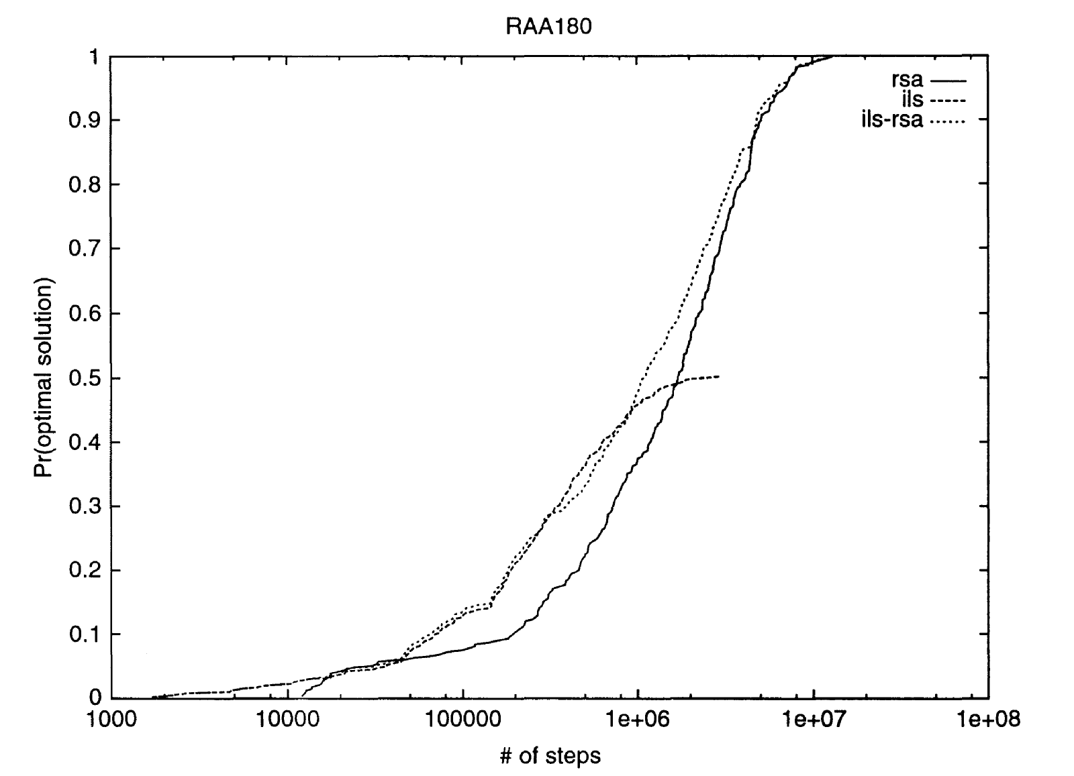
Figure 3 From Abdelbar[13], Number of Iterations versus Percent of Optimal Solution for ILS-RSA, RSA and ILS alone
Chivers et al. use a hierarchical particle swarm optimization technique (HPSO) [14] and an evolutionary algorithm (EA) [15] which uses point-wise splicing as our method does. Using the particle swarm technique, Chivers reports a mean score of 12,155 (89% of optimal) for raa180. The minimum score found out of 3,584 trials was 11,381 (95% of optimal). Using the evolutionary algorithm, Chivers’ best results were reported with an initial population size of 100 with 1000 iterations for each trial. The average solution was 11,574 (93.5% of optimal) with the best solution out of 543 trials being 11,374 (95% of optimal).

In our sets of experiments, our best configuration (more on configurations in the next section) had an outer skin which holds the best solution passed to it so far, a grandparent membrane holding seven parent membranes, and each parent membrane has three child membranes. The Repair membrane within each of those child membranes is seeded initially with 50 random possible solutions. The nomenclature we use for such a membrane is 1-7-3 indicating one collective membrane, seven sub-membranes each with 3 sub-membranes. In running this membrane computer, an iteration is the firing of one rule per membrane per round. Thus, for 100 iterations, 100 rule firings could occur per membrane. Notice that this rule firing mechanism is not equivalent to Păun’s maximal parallelism where as many rules fire per round as possible [1]. Results for the 1-7-3 system are given in Table 2. As can be seen, this configuration quickly achieves 90% of the optimal within 100-150 iterations, 95% of the optimal within 300-400 iterations, and 98% of the optimal after 700 iterations.

Number of Iterations | Mean Score | Min Score | % of the Optimum
100 | 12158 | 12011 | 89.00
200 | 11497 | 11100 | 94.12
300 | 11423 | 11330 | 94.73
400 | 11084 | 11019 | 97.62
500 | 11087 | 10972 | 97.60
600 | 11062 | 11019 | 97.82
700 | 11036 | 10977 | 98.05
800 | 11019 | 11019 | 98.20
900 | 11059 | 10994 | 97.85
1000 | 10929 | 10821 | 99.01
Table 2: 1-7-3 CBA Membrane Computer Experiments
0.88
0.9
0.92
0.94
0.96
0.98
1
100
600
1100
1600
1-4-5
1-2-10
1-10-2
1-1-20
1-7-3
Figure 4 Percentage of Optimal vs. Number of Iterations for Configurations

Analysis of Topologies
Of significant interest in membrane computing is the appropriate nesting of membranes. Should membranes be nested deeply but narrowly (few children per membrane) or shallowly but broadly (many children per membrane)? In order to answer this question for the cost-based abduction membrane computer, we sampled a number of configurations with approximately the same number of leaf (or bottom) membranes: 1-1-20, 1-2-10, 1-4-5, 1-7-3, and 1-10-2. Each bottom membrane was seeded with 50 randomly generated possible solutions. As indicated in Table 3 and illustrated by Figure 3 all of these configurations reached 90% within 100-150 iterations, 95% within 250-350 iterations, and 98% within 700-1000 iterations.
Broader trees seem to be converging faster (particularly in the 100-200 iteration range), but by 700 iterations there is relatively little difference. One possible difference is the very shallow trees (1-1-20 and 1-2-10) rarely showed improvement after iteration 100.

# of Iterations | 1-1-20 | 1-2-10 | 1-4-5 | 1-3-7 | 1-10-2
100 | 12202 (88.7) | 12103 (89.4) | 11719 (92.3) | 12158 (89.0) | 11501 (94.1)
200 | 11581 (93.4) | 11521 (93.9) | 11438 (94.6) | 11497 (94.1) | 11366 (95.2)
300 | 11541 (93.8) | 11194 (96.6) | 11203 (96.6) | 11423 (94.7) | 11261 (96.1)
400 | 11132 (97.2) | 11112 (97.4) | 11189 (96.7) | 11084 (97.6) | 11153 (97.0)
500 | 11084 (97.6) | 11052 (97.9) | 11122 (97.3) | 11087 (97.6) | 11027 (98.1)
600 | 11024 (98.2) | 11040 (98.0) | 11129 (97.2) | 11061 (97.8) | 11048 (97.9)
700 | 11026 (98.1) | 11022 (98.2) | 11124 (97.3) | 11036 (98.1) | 11007 (98.3)
800 | 11066 (97.8) | 11016 (98.2) | 11150 (97.0) | 11019 (98.2) | 11036 (98.1)
900 | 11019 (98.2) | 11008 (98.3) | 11072 (97.7) | 11058 (97.8) | 11019 (98.2)
1000 | 11012 (98.3) | 11007 (98.3) | 11000 (98.4) | 10929 (99.0) | 10991 (98.5)
Table 3:Topology Experiments: Mean Score (and % of Optimal Score)
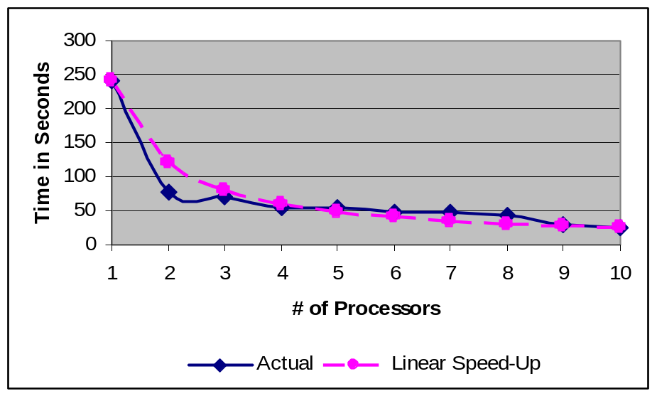
Figure 5 Actual Performance in Solving a CBA Problem Using 1 through 10 processors. For contrast, the graph showing what linear speedup would look like is included as well.

Implementation in a Cluster Environment
A broad topology makes for a relatively easy implementation for a small number of cluster computers. We implemented our membrane computer on a cluster computer environment with up to 11 separate processors (specifically 6 Dell PowerEdge 1850 Servers with 2 Dual Core Xeon processors 2.8GHz memory using custom socket implementation). Using a 1-10-3 topology for solving CBA, we obtained the results indicated in Figure 5. For this graph, the time was recorded until the membrane computer reached a solution that was 95% of optimal. For each number of processors, twenty trials were run and the average plotted
As illustrated, when run on one processor, the average time is 240 seconds. When two processors are used, the average time was reduced to 64 seconds, more than would be expected from a linear speedup. The explanation for this super-linear speedup can be found in the way communication was handled between membranes. The top membrane acted like a web server with the submembranes being clients. As both server and client have the same host machine, the amount of time the processor spends in I/O is substantially increased. With multiple processors, the server and clients are on different hosts in the cluster environment and the amount of time each processor spends in I/O is much less.
As we add more processors, linear speedup is closely maintained. This result with a relatively small number of processors indicates that membrane computers can take good advantage of parallelization. Future work will examine the effect of scaling up to medium-scale (50-100 nodes) and large-scale (> 1000 nodes) environments.

Conclusion
The most important contribution of this effort is the application of membrane computing to the domain of cost-based abduction. Not only have we shown that this paradigm is feasible for the CBA problem domain, our results have been an improvement on some previously published work.

Future Work
Immediate future work will proceed in two areas: 1) efficient parallelization of our membrane architecture on cluster computers, and 2) application of our approach to other domains beyond CBA.
Efficient Parallelization to Cluster Computers
Several groups have shown that membrane computing can be efficiently implemented on cluster computers [15, 16]. Our interface is designed so that the human designer may specify the cluster to which each membrane is to run. However, our goal is to dynamically monitor the communication between membranes and the CPU-time required for each membrane. Intuitively, membranes with heavy inter-communication will be moved to the same cluster while a membrane that is CPU-intensive but relatively light on cellular communication will be given its own processor. Our experiments will be conducted on both medium-scale (50-100 nodes) to large-scale (>1000 nodes) Beowulf clusters.
Application to Other Domains
Preliminary work has shown promise at using almost exactly this architecture to find approximate solutions for theoretical problems such as N-Queens and Traveling Salesman. We are currently exploring using this paradigm to problems in vision processing and QTL analysis in bioinformatics.

References
- G. Păun, Computing with membranes, Journal of Computer and System Sciences, 61(10), 2000, pp. 108-143.
- G. Păun and G. Rozenberg, A Guide to Membrane Computing, Theoretical Computer Science 287(1), 2002, pp. 73-100.
- J.R. Hobbs, M.E. Stickel, D.E. Appelt, and P. Martin, Interpretation as abduction, Artificial Intelligence, Vol. 63, 1993, pp. 69-142.
- E. Charniak, and S.E. Shimony, Cost-based abduction and MAP explanation, Artificial Intelligence 66, 1994, pp. 345-374.
- Ashraf M. Abdelbar, Approximating cost-based abduction is NP-hard” Artificial Intelligence, Vol. 159, No.1-2, November 2004, pp. 231-239.
- E. Charniak, and S. Husain, A new admissible heuristic for minimal cost proofs, Proceedings AAAI National Conference on Artificial Intelligence, 1991, pp. 446-451.
- E. Charniak, and S.E. Shimony, Probabilistic semantics for costbased abduction, Proceedings AAAI National Conference on Artificial Intelligence, 1990, pp. 106-110.
- E. Santos Jr., A linear constraint satisfaction approach to cost-based abduction, Artificial Intelligence, Vol. 65, 1994, pp. 1-27.
- S. Kato, S. Oono, H. Seki, and H. Itoh, Cost-based abduction using binary decision diagrams, Proceedings Industrial and Engineering Applications of Artificial Intelligence, 1999, pp. 215-225.
- A.M. Abdelbar, M.A. El-Hemaly, E.A.M. Andrews, and D.C. Wunsch, Recurrent neural networks with backtrack-points and negative reinforcement applied to cost-based abduction, Neural Networks, Vol. 18, August 2005.
- A.M. Abdelbar, and M. Mokhtar, A k-elitist MAX-MIN ant system approach to cost-based abduction, Proceedings IEEE Congress on Evolutionary Computation, 2003, Vol. 4, pp. 2635-2641.
- A.M. Abdelbar, Heba A. Amer, Finding least-cost proofs with population-oriented simulated annealing, Proceedings ANNIE-06, 2006, pp. 79-84.
- A. Abdelbar, S. Gheita, and H. Amer, Exploring the fitness landscape and the run-time behaviour of an iterated local search algorithm for cost-based abduction, J. of Experimental & Theoretical Artificial Intelligence, 18(3), 2006, pp. 365-386.
- Shawn T. Chivers, Gene A. Tagliarini, and Ashraf M. Abdelbar, Finding Least Cost Proofs Using a Hierarchical PSO, Proceedings IEEE Swarm Intelligence Symposium, Honolulu, Hawaii, April 2007, pp. 156-161
- S. Chivers, G. A. Tagliarini, and A.M. Abdelbar, An Evolutionary Optimization Approach to Cost-Based Abduction, with Comparison with PSO, Proceedings 2007 IEEE International Joint Conference in Neural Networks, 2007.
- G. Ciobanu, G. Wenyuan, A P system running on a cluster of computers, Proceedings of Membrane Computing, Lecture Notes in Computer Science, v. 2933, 2004, pp. 123-150.
- A. Syropoulos, E. Mamatas, P. Allilomes, and K. Sotiriades, A distributed simulation of P systems, Proceedings of the Workshop onMembrane Computing, 2003, pp. 455-460. Motorola Semiconductor Data Manual, Motorola Semiconductor Products Inc., Phoenix, AZ, 1989.

 Manuscript received May 14, 2008. This research is supported by a subcontract with Lexxle Inc. through Air Force Research Laboratory contract FA875006C0032. Curry I Guinn is with the Department of Computer Science at the University of North Carolina Wilmington, Wilmington, NC, USA 28428. Phone: 910-962-7937; Fax: 910-962-7457, email: guinnc@uncw.edu. William Shipman is with the Department of Computer Science at the University of North Carolina Wilmington. (e-mail: wjshipman@gmail.com). Ed Addison is with Lexxle, Inc., Wilmington, NC, USA, 28405. (e-mail: ed@teradisc.org).

